Metacognitive Scaffolding: Supporting Cross-Session Search for People with Working Memory Constraints
Student Name: MD Telot, MSc in Computer Science
Start Date/Semester: Winter 2026
Project Revised: (Oct 25, 2026)

Abstract
Complex search tasks often lead searchers to use exploratory search processes (Marchionini 2006; White and Roth 2009), and these tasks commonly extend across multiple search sessions (Li et al. 2020). Because these activities often span multiple search sessions (Li et al. 2020), users must reacquaint themselves with their previous activities and the documents they found before they can continue, which requires considerable cognitive effort (Gomes et al. 2022). Because working memory capacity influences how searchers monitor and make sense of information (Choi and Arguello 2025; Choi et al. 2023), these demands may be harder to meet for searchers with lower capacity. This burden is particularly acute for individuals with reduced working memory capacity (Choi and Arguello 2025), including some users with dyslexia, who show lower working memory spans than adults without dyslexia (Smith-Spark and Fisk 2007) and for whom academic search combines reading, working memory, and attention demands (Seihoon et al. 2026), or ADHD, where limited working memory capacity makes it harder to retain task-relevant information (Zhu et al. 2026). These searchers with lower working memory capacity may be unable to keep their search goal and what they have found so far in mind at the same time, particularly once something encountered in the results pulls their attention away from the original need (Choi and Arguello 2025).
Exploratory search places further demands on these searchers. Planning, monitoring, and evaluating are the core metacognitive activities in exploratory search (Crescenzi et al. 2021), so searchers need a plan to monitor and evaluate their progress against. Searchers with dyslexia struggle with spelling and query formulation (Beveridge et al. 2022), tend to read only the part of a source that looks relevant and to favour sources that match what they already know (Beveridge et al. 2022), find it harder to tell relevant results from non-relevant ones (Fourney et al. 2018), and take longer and report more difficulty extracting information from dense webpage text (Palani et al. 2020). Searchers with lower working memory capacity have more difficulty connecting newly discovered information to what they already know and deciding whether to continue a direction or change strategy (Choi and Arguello 2025). They also have more difficulty maintaining the thread of a search (Choi and Arguello 2025). Organizing found information has been argued to be an important part of supporting exploratory and cross-session search (Orin and Hoeber 2025), and searchers using OrgBox reported more support for planning, monitoring, and evaluating than with a rich-text note tool, where they create, label, and rearrange the boxes themselves (Crescenzi et al. 2021). Although, study has found exploratory search is cognitively demanding, and search engines offer little support for cognitive and metacognitive activities such as planning and monitoring (Li et al. 2023). Which is why these users need support and any support must also leave the searcher in control, because excessive automation can reduce engagement with reflection, evaluation, and knowledge construction (Risko and Gilbert 2016). That being said, if AI-generated representations of earlier search states are happen to be used in this case, those should be transparent, editable, and source-grounded (Zhu et al. 2026; Momeni and Hoeber 2026).
This thesis therefore proposes an LLM-assisted exploratory search interface that supports each of these demands while leaving the searcher in control. To support planning, an LLM divides the searcher’s goal into candidate sub-goals, based on the search goal and what the searcher already knows, with every candidate being an angle the searcher has not mentioned, and structured support for setting sub-goals has been found to shape downstream learning outcomes (Urgo and Arguello 2024). The LLM also generates candidate queries for each sub-goal, to reduce the query formulation difficulty described above. To support evaluation, each search result shows which of the sub-goals the searcher selected it matches best, through the order of its tags, and the results themselves are ordered by how well they match the sub-goal being searched, so the searcher does not have to judge relevance unaided, and the interface flags new ideas that keep appearing in the results the searcher saves, so the searcher can add a sub-goal, continue, or switch direction. To support organization, saved results are filed under the sub-goals set during planning, so the searcher does not build the structure by hand. To support monitoring and cross-session search, visual progress indicators show progress on each sub-goal within and across sessions, saved results can be viewed by sub-goal and by session, and a returning searcher can continue the last activity or switch to any sub-goal. These progress cues use little text, in response to the dense-text difficulty above, and follow the principle that a cue helps recall when it matches how the information was originally encoded (Tulving and Thomson 1973). The searcher makes the final decision at each step, including which sub-goals to keep and which sub-goal a saved result goes under, and each AI-generated judgment can be inspected to see why it was made. A controlled user study comparing the interface against a baseline will examine how it influences search behavior, sensemaking, and perceived cognitive load.
CCS Concepts: Human-centered computing → Interactive systems and tools; Information systems → Search interfaces; Human-centered computing → Accessibility; Computing methodologies → Natural language processing
Keywords: exploratory search, metacognition, working memory, large language models, scaffolding, cross-session search, neurodivergent users
Received: 28 April 2026

User Persona: Jamie Chen
Jamie Chen, first-year student, Age: 19, Location: Regina, Saskatchewan, Canada University: University of Regina, Program: B.A., Geography and Environmental Studies Diagnosis: Dyslexia.

About Jamie
Jamie has dyslexia, which comes with lower working memory [19, 28]. Lower working memory changes how Jamie searches [4], and Jamie stays unsure whether a search found what was needed [1].
Jamie is taking a first-year Geography course that includes a module on urban planning. For the course project, Jamie has chosen to focus on the impact of green spaces on human well-being. Green spaces include public parks, community gardens, tree-lined streets, green spaces around schools, hospitals and government buildings, and nature conservation areas. Human well-being includes physical health, emotional and mental health, and social engagement. The topic is new to Jamie.

Behavioral considerations
- Rewrites a query several times before running it and rechecks the spelling and phrasing each time [1]
- Favours sources that match what Jamie already knows [1]
- Reads only the sentence or section that looks relevant [1]
- Drops a source when its first sentence differs from what Jamie expected [1]
- Reads more slowly and makes more reading errors than searchers without dyslexia [19]
- Judges fewer documents as irrelevant than searchers without dyslexia [19]
- Abandons queries more often [4]
- Spends more time on the search results page before choosing what to open [4]
- Builds more queries from words and ideas found in results already seen [4]
- Checks less whether new information fits the goal of the search [4]

Frustrations
- Remains unsure that a search found useful and relevant information, even after finishing the assignment [1]
- Worries that a misspelled name will return nothing useful [1]
- Has difficulty keeping track of the queries issued and the results already examined [35]
- Needs to find again information seen in an earlier session and to become familiar with the task again after time away [16]
- Needs to apply, analyze and evaluate information when a search continues in a later session [36]

Goals
- Find a diverse set of high-quality resources that show green spaces and well-being from different perspectives
- Understand the topic well enough to examine the saved resources more carefully later
- Feel confident while searching that the search is going well
- Pick a search up again after a break with less effort spent working out what was already found and why

Tasks
- Explore the academic literature on green spaces and human well-being
- Rewrite and refine queries
- Judge from the search results which resources are worth saving
- Save a diverse set of resources into a workspace
- Return to an earlier search after a break and work out where it stood

Scenario: a search over several days
On Monday afternoon Jamie sits down between classes to start the course project on green spaces and well-being. The topic is new, and time is short, so the plan for now is to save a diverse set of good resources and read them later. Jamie types a query, doubts the spelling, and rewrites it several times before running it [1]. Jamie is unsure whether the wording covers the topic [1]. A few results look promising, but Jamie cannot read the articles now and can only judge them from what the result shows. Jamie skims the opening sentence of each, keeps the ones that match what Jamie already knows [1], and saves two, one about physical health and one about mental health. Class starts while Jamie is still unsure whether the search is going well, and the search stops there.

On Wednesday Jamie opens the workspace again with only a general memory of Monday. The queries Jamie tried, the results Jamie skipped and the reasons for saving those two resources are no longer in mind. Before adding anything new, Jamie has to work out what was already found, why those two resources were saved, which perspectives are still missing, and where to go next [16]. Jamie is again unsure whether the search is going well, and time that could go to finding new resources goes to reconstructing Monday.

Problem Statement
Complex search tasks often trigger exploratory search processes (Marchionini 2006; White and Roth 2009; Hoeber and Shukla 2022) that are inherently iterative (White and Roth 2009), non-linear, as a searcher's uncertainty can rebound when new subtopics are discovered (Jiang 2014; Hoeber and Shukla 2022), and multi-faceted (Hoeber, Pirmoradi, et al. 2024). Unlike simple information lookup, exploratory search requires searchers to take an active role, moving from exploratory browsing (discovery, learning, and investigation) toward focused searching (query reformulation, result examination, and information extraction) as their understanding develops (Hoeber 2025), while planning, monitoring, and evaluating their own search process (Crescenzi et al. 2021). Because these tasks cannot be satisfied by a single query or result (Hoeber 2025), they frequently extend across multiple search sessions (Li et al. 2020). As a result, searchers must maintain an evolving mental model of their search process, including previous decisions, information already reviewed, unresolved information needs, and possible next steps, across interruptions, as everyday search tasks commonly span days, weeks, or months (Li et al. 2020).
Three concepts underpin this thesis. Metacognition refers to the conscious awareness of one's own knowledge of a task, a topic, and one's thinking, together with the conscious management of the related cognitive processes; in exploratory search it appears as planning, monitoring, and evaluating one's search (Crescenzi et al. 2021). Sensemaking refers to making sense of a topic by developing a representation of it, encoding new information into that representation, and modifying the representation when information does not fit (Choi and Arguello 2025). Working memory refers to the ability to maintain and manipulate information in memory when it is no longer perceptually present (Choi and Arguello 2025).
Research in cognitive science suggests that managing complex tasks depends on both internal cognitive processes and interactions with external representations and contextual cues. The encoding specificity principle proposed by Tulving and Thomson (Tulving and Thomson 1973) demonstrates that successful memory retrieval depends on the availability of appropriate contextual cues. This indicates that when individuals return to a previously interrupted activity, effective support requires cues that help reconstruct the context in which stored information was originally interpreted, in addition to access to that information. Norman's concept of cognitive artifacts further describes how external structures can support human thinking by reducing the need to internally maintain complex information (Norman 1993).
However, external cognitive support introduces an important design tension. While external representations can reduce cognitive demands, excessive reliance on external tools may alter how individuals engage with memory and reasoning. Risko and Gilbert's work on cognitive offloading demonstrates that people frequently use external resources to reduce cognitive effort, but such offloading may influence how information is processed, remembered, and retrieved (Risko and Gilbert 2016). This creates an important challenge for GenAI systems: while AI-based support can reduce unnecessary cognitive burden, excessive automation may encourage users to delegate reasoning processes that are important for learning, reflection, and knowledge development.
These cognitive challenges are particularly relevant in exploratory search, where users must maintain an internal understanding of the search process while simultaneously processing new information. Studies of everyday cross-session search show that returning searchers reacquaint themselves through methods such as re-reading saved information and their own notes, and that some searchers use no specific method at all (Li et al. 2020). Studies that designed interfaces for cross-session search note that resuming a search requires considerable cognitive effort (Gomes et al. 2022) and that most public digital library interfaces offer little beyond a list of saved resources to support it (Hoeber, Islam, et al. 2026). Resuming a search therefore requires reconstructing the cognitive state that guided earlier searching, in addition to retrieving previous materials. Search Timelines externalizes search activity as a timeline of queries and saved resources, designed to help searchers review their previous actions when they resume a search (Hoeber, Islam, et al. 2026).
For individuals with reduced working memory capacity (Choi and Arguello 2025; Choi et al. 2023), including some users with dyslexia (Smith-Spark and Fisk 2007; Seihoon et al. 2026) or ADHD (Zhu et al. 2026), maintaining this cognitive context can be particularly demanding. Research in information retrieval shows that working memory capacity influences how searchers perform monitoring, evaluation, and sensemaking during complex search tasks (Choi and Arguello 2025; Choi et al. 2023). Searchers with lower working memory capacity may experience increased difficulty maintaining the "thread" of the search, connecting newly discovered information to what they already know, and determining whether to continue an existing direction or change strategy (Choi and Arguello 2025; Choi et al. 2023). However, even users without identified cognitive limitations may encounter working-memory challenges during long-term search activities because exploratory tasks require simultaneous management of goals, evidence, uncertainty, and emerging understanding.
Current search interfaces provide limited support for these cognitive demands. Prior research has shown that organizing information, visualizing relationships, and supporting reflective activities can improve exploratory search by externalizing parts of the search process (Crescenzi et al. 2021; Hoeber and Shukla 2022; Li et al. 2023). However, users remain responsible for monitoring progress, evaluating evidence, identifying knowledge gaps, and deciding when their understanding should change (Choi et al. 2023; Crescenzi et al. 2021).
Recent developments in generative AI introduce new opportunities for supporting these challenges. LLM-based systems can support learning-oriented search through conversation (Yang et al. 2025) and generate summaries that help searchers resume a search across sessions (Momeni and Hoeber 2026). Co-design work with GenAI has also proposed reflective prompts as a way to support task management (Zhu et al. 2026). However, delegating synthesis to an automated system is a form of the cognitive offloading described above (Risko and Gilbert 2016), and it may bypass users' own searching and evaluation processes, reducing opportunities for learning and metacognitive engagement. Therefore, effective GenAI support requires balancing cognitive assistance with preservation of user agency.
This research addresses this challenge by investigating how GenAI-assisted exploratory search systems can provide scaffolding that supports metacognition and cross-session continuity while reducing the demands on a searcher's working memory and avoiding excessive cognitive offloading. The proposed system uses GenAI as a collaborative partner that provides retrieval cues, externalizes important information, maintains provenance of evolving understanding, and supports reflection throughout the search journey.

Related Work
This research is situated at the intersection of exploratory search, cross-session search, and scaffolding for metacognition. The review begins with the search context, exploratory search and cross-session search, and then turns to the searcher: dyslexia, working memory, and attention, and how they affect cross-session exploratory search. Metacognition follows as a concept. The review closes with search interface design, visualization, and scaffolding, including scaffolding that uses generative AI, for metacognition and for resuming a search.

Exploratory Search and Cross-Session Search
Marchionini (2006) distinguishes lookup from the learning and investigation activities that make up exploratory search, and White and Roth (2009) describe exploratory search as an information-seeking problem context that is open-ended, persistent, and multifaceted, and as information-seeking processes that are opportunistic, iterative, and multitactical. Complex search tasks differ from lookup tasks because the information need is open-ended, multi-faceted, ill-defined, or ambiguous, and the searcher must pursue it from a position of limited knowledge about the topic (Hoeber 2025). Such tasks are multi-faceted, ill-defined, and open-ended (Hoeber, Pirmoradi, et al. 2024), and the search process is non-linear: a searcher's uncertainty can rebound as new subtopics are discovered, returning them to exploratory browsing (Jiang 2014; Hoeber and Shukla 2022).
Complex search tasks that lead to exploratory search processes frequently extend beyond a single interaction period because users require time to gather information, process findings, consult additional resources, or reconsider their initial direction. Cross-session search refers to information-seeking activities where users suspend and later resume a search task across multiple sessions, potentially separated by hours, days, or longer periods (Li et al. 2020). Unlike single-session search, cross-session search introduces an additional cognitive challenge: users must reconstruct their previous understanding, including their original goals, search pathways, evaluated information, and unresolved information needs.
Research on everyday cross-session search demonstrates that interruptions are a natural characteristic of information seeking. Li et al. investigated how users conduct searches across multiple sessions and found that people frequently divide search activities because of task complexity, time constraints, or the need to process information before continuing the search (Li et al. 2020). These interruptions create a requirement for users to maintain continuity between sessions, even when the search process is temporarily inactive.
Resuming a search requires searchers to reconstruct the context in which information was discovered and interpreted, in addition to retrieving what they previously accessed. Gomes et al. designed and evaluated an academic digital library interface for cross-session and cross-device search, motivated by the observation that resuming a search requires significant cognitive effort because searchers must reacquaint themselves with previous activities and previously discovered documents (Gomes et al. 2022). In everyday cross-session search, people commonly reacquaint themselves by re-reading saved information and their own notes, or by searching again for information they had already found (Li et al. 2020). Such artifacts preserve elements of the search process, but in typical workspaces much of the context for why a resource was saved is lost (Hoeber, Islam, et al. 2026).
This challenge can be understood through the encoding specificity principle proposed by Tulving and Thomson, which suggests that memory retrieval depends strongly on the availability of contextual cues associated with the original encoding process (Tulving and Thomson 1973). When users return to a previous search after an interruption, access to documents alone may be insufficient because the contextual cues that supported earlier interpretation and decision making may no longer be available. Effective cross-session support therefore requires mechanisms that help users reconstruct the cognitive state associated with previous search activity.
Cross-session search is also closely connected to metacognitive regulation. Returning users must determine whether to continue from their previous point, change their strategy, or pursue a new direction based on what they now understand. Li and Capra examined stopping behaviors in cross-session searches and found that the reasons users stop searching are significantly related to the type of information encountered during the session, though they found no significant relationship between stopping reasons and the cognitive activity being performed at the time of stopping. Notably, they observed that nearly half of all sessions reached the highest ('evaluate') level of cognitive activity regardless of the reason the session was stopped (Li and Capra 2024). This indicates that session boundaries represent changes in the user's cognitive state and search strategy.
Hoeber's persistence principle holds that exploratory search interfaces should persist a searcher's interactive selections, within a session and across sessions, so that they inform subsequent search activity and support task resumption (Hoeber 2025). Similarly, Search Timelines represents previous search activities as an interactive history, designed to help searchers revisit earlier search paths and reacquaint themselves with past activity before resuming (Hoeber, Islam, et al. 2026).
Overall, cross-session search introduces a fundamental design challenge: systems must support continuity of understanding as well as continuity of access. Preserving documents, queries, or interaction logs alone does not guarantee that users can effectively resume a complex search. Instead, interfaces must help users reconstruct previous reasoning, recognize progress, and decide how to proceed.

Dyslexia, Working Memory, and Attention
Working memory refers to the limited cognitive system responsible for temporarily maintaining and manipulating information required to perform complex tasks (Choi and Arguello 2025). Unlike long-term memory, working memory has constrained capacity, requiring individuals to selectively maintain task-relevant information while processing new information. This capacity is not uniform across individuals: in the cognitive-psychology literature on dyslexia, Smith-Spark and Fisk found that adults with dyslexia had significantly lower working memory spans than controls on every verbal task tested and on the spatial complex span task, but showed a less consistent impairment on simpler visuospatial storage measures such as the Corsi block span, and no overall deficit on the spatial updating task apart from the early, most novel trials (Smith-Spark and Fisk 2007). This pattern suggests that the deficit in dyslexia is tied to the active management of information, holding, revising, and updating it under load, rather than to visuospatial memory in general, which is precisely the kind of demand exploratory search places on a user as they track a shifting goal and integrate new findings. This indicates that the working memory constraints discussed throughout this thesis have a basis in dyslexia's cognitive profile itself rather than being inferred solely from search behavior. In exploratory search specifically, working memory is engaged repeatedly because users must simultaneously maintain search goals, evaluate retrieved information, compare multiple sources, track previous decisions, and determine future actions (Choi and Arguello 2025).
The cognitive demands of exploratory search become particularly challenging because searchers must manage both information processing and search process regulation. While reviewing documents, users must remember why information was collected, how it relates to previous findings, and whether it contributes to their evolving understanding of the problem. Choi and Arguello demonstrate that working memory capacity significantly influences search and sensemaking behaviors, showing that individuals differ in their ability to monitor information, connect knowledge, and maintain awareness of task progress (Choi and Arguello 2025). Similarly, Choi et al. found that users with varying cognitive abilities respond differently to knowledge representation tools, suggesting that interface support must account for individual differences (Choi et al. 2023).
This general relationship between working memory and search behavior has also been examined specifically for searchers with dyslexia. MacFarlane et al. found that phonological working memory, measured via a digit-span task, was significantly correlated with how many documents searchers judged irrelevant during information searching. This was the first empirical evidence linking phonological working memory capacity to relevance-judgment behavior in dyslexic and non-dyslexic searchers (MacFarlane et al. 2012). More recently, Palani et al. used eye-tracking to compare searchers with and without dyslexia across a multi-stage search task and found that searchers with dyslexia issued more queries, made significantly more phonetic query errors, and examined more search results using a less selective reading pattern than the F-shaped scan typical of the control group, with some increase in self-reported cognitive effort, significant for one of the two tasks, once the task required reading further into individual webpages (Palani et al. 2020). Together with Smith-Spark and Fisk's clinical findings, this converging evidence, from cognitive psychology and from information retrieval specifically, motivates treating working memory capacity as a design-relevant individual difference rather than relying on a single research group's account of how it affects search.
Attention is closely associated with working memory. Working memory is involved in attentional control (Choi and Arguello 2025). For students with ADHD, Zhu et al. note that limited working memory capacity together with difficulties in inhibitory control can make it harder to filter out irrelevant details and retain task-relevant information (Zhu et al. 2026). For searchers with dyslexia, Seihoon et al. describe the demands of academic search as a combination of reading, working memory, and attention, and provide workspace cues to help searchers who become distracted reorient themselves to the task at hand (Seihoon et al. 2026).
Within cross-session exploratory search, working memory limitations are particularly important when a search extends over several sessions. Searchers often need to remember previous queries, document relationships, emerging concepts, and unresolved information needs while examining new information. When these elements exceed working memory capacity, users may lose awareness of previous reasoning, repeat unsuccessful search paths, or fail to connect newly discovered information with existing knowledge structures (Choi and Arguello 2025). These challenges motivate the development of interfaces that externalize important information to reduce the demands on working memory while preserving human interpretation and decision making.

Metacognition
Metacognition refers to an individual's awareness and regulation of their own cognitive processes during task performance (Crescenzi et al. 2021). In exploratory search, metacognition is essential because searchers must not only judge the relevance of retrieved information but also monitor their progress, evaluate whether their search strategy is working, and decide when a change in direction is necessary (Crescenzi et al. 2021). Unlike lookup tasks with clearly defined goals, exploratory search begins with exploratory browsing to learn broadly about a topic and shifts toward focused searching as the searcher's uncertainty decreases, although the process is not strictly linear (Hoeber 2025).
Prior research identifies several regulatory activities involved in metacognitive search behavior: planning, which involves establishing search objectives and identifying possible strategies; monitoring, which involves maintaining awareness of progress and remaining uncertainties; and evaluation, which involves judging whether the plan is working and whether the search should continue, change direction, or stop (Crescenzi et al. 2021). These activities require users to maintain an understanding of both the external information environment and their own evolving knowledge state.
Because this thesis scopes exploratory search to the search results page itself, rather than to how a searcher subsequently reads and learns from a full document, it adopts planning, monitoring, and evaluating as its guiding metacognitive activities, following Crescenzi et al.'s characterization of these as core, measurable regulatory activities relevant to exploratory search (Crescenzi et al. 2021), rather than the broader self-regulated learning (SRL) models developed for learning-oriented tasks that extend beyond the search results page. This motivates this thesis's emphasis on scaffolding these three specific regulatory activities rather than treating metacognition as an undifferentiated form of self-awareness. Separately, in a search-as-learning study, Urgo and Arguello show that structured support for setting self-set subgoals with ideal characteristics (a specific action, content, criteria for success, and a timeframe) is associated with better downstream learning outcomes, particularly knowledge retention, than having no subgoal-setting support at all, indicating that how a search goal is formed shapes a searcher's subsequent progress (Urgo and Arguello 2024); this finding is used later in this review as supporting evidence for scaffolding goal formation specifically during planning, not as a theoretical framework adopted by the thesis as a whole.
The importance of metacognition becomes particularly apparent in learning-oriented and exploratory search tasks. Searchers construct interpretations, comparing evidence, identifying relationships, and developing conceptual understanding. Hoeber argues that exploratory search interfaces should support discovery, learning, and investigation through lightweight visual and interactive additions to the familiar query box and results list, rather than replacing it (Hoeber 2025). Similarly, Crescenzi et al. demonstrate that exploratory search requires mechanisms that help users actively organize and reflect on their search activities because understanding emerges through interaction with information (Crescenzi et al. 2021).
However, maintaining metacognitive awareness during complex search introduces significant cognitive demands. Users must simultaneously remember their original objectives, track the directions already searched, evaluate evidence, and determine appropriate next actions. Recent work by Choi and Arguello shows that working memory capacity influences how searchers perform monitoring and sensemaking activities (Choi and Arguello 2025). Their findings indicate that search support mechanisms should consider variations in users' cognitive resources rather than assuming a uniform search experience. Working memory and metacognition are different concepts: working memory is a capacity limit, whereas metacognitive regulation is a strategy that searchers can be supported in using. The two are complementary, but this thesis treats them separately.
Consequently, effective systems for exploratory search must help users maintain awareness of their search process, externalize important information, and support reflection without removing responsibility for interpretation and decision making. The final section of this review covers how interface design, visualization, and scaffolding, including scaffolding that uses generative AI, have been used to support these activities.

Search Interface Design, Visualization, and Scaffolding
From a cognitive perspective, human problem solving is not restricted to internal mental processes alone. Norman introduced the concept of cognitive artifacts to describe external representations that support human thinking by making information easier to perceive, manipulate, and reason about (Norman 1993). This perspective provides an important theoretical foundation for search interface design: external structures should support human reasoning and complex activities.
The use of external representations, however, introduces an important design consideration. While external tools can reduce cognitive demands by allowing users to offload information, excessive dependence on external support may influence how individuals engage with memory and reasoning processes. Risko and Gilbert describe this phenomenon as cognitive offloading, where people use external resources to reduce internal cognitive effort, while noting that such strategies may alter how information is processed and remembered (Risko and Gilbert 2016). Therefore, effective support systems must balance reducing unnecessary mental burden while preserving the user's active engagement with the search and sensemaking.
Because working memory is limited, scaffolding can also reduce unnecessary cognitive demands by externalizing information that searchers would otherwise need to hold in mind, so that their limited cognitive resources remain available for higher-level reasoning, interpretation, and decision making.
The term scaffolding originates in developmental psychology, where it describes contingent support that helps a learner accomplish a task beyond what they could achieve unassisted, and which is progressively withdrawn as competence increases (Wood et al. 1976). Within information retrieval, the concept has been adapted in several forms. Câmara et al. added instructional scaffolding to the search results page, such as a curated list of subtopics, and found that it changed search behavior without significantly improving learning gains, while real-time feedback on the searcher's exploration of the topic space drew attention toward the feedback indicator and away from the learning material itself (Câmara et al. 2021). Palani et al. placed search suggestions within the emerging structure of a searcher's own notes, which helped searchers keep track of new suggestions and connect newly discovered information to what they already knew (Palani et al. 2022). The concept has also been used to describe interface, visualization, and system support for the regulatory activities involved in exploratory search (Crescenzi et al. 2021), and, most recently, to describe interactive passage highlighting and AI-generated summarization added to an organizing workspace, which Momeni and Hoeber term "task-resumption scaffolds" and whose separate and combined effects on metacognition and task resumption they compared experimentally (Momeni and Hoeber 2026).

Interface Design and Visualization
Early approaches to metacognitive support in exploratory search focused on providing users with interactive spaces for organizing and managing information. These systems recognize that searchers often need to construct their own representations of an emerging information space rather than simply consume ranked results.
Crescenzi et al. studied OrgBox, a search interface extension designed to support metacognitive activities during exploratory search. OrgBox lets users create, label, and rearrange boxes of saved information. In a within-subjects study (N=24), participants using OrgBox created more groupings and saved more text than with a rich-text note tool, and rated it as giving more support for monitoring, evaluating, and planning their search (Crescenzi et al. 2021).
More recent work has extended this idea beyond individual document organization. Orin and Hoeber designed WESearch, a public digital library search interface with nested workspaces "that let searchers sort saved resources into a two-tier structure, by overall task and by the sub-goals nested within it, arguing that organizing found information is an important aspect of supporting exploratory and cross-session search (Orin and Hoeber 2025).
Choi et al. investigated how knowledge representation tools influence searchers with different cognitive abilities and found that external organization mechanisms can provide valuable support, but their effectiveness depends on individual cognitive characteristics (Choi et al. 2023). This finding suggests that working memory scaffolding should not impose a fixed organizational strategy. Instead, systems should provide flexible structures that users can adapt according to their own reasoning processes.
Visualization provides another mechanism for supporting metacognition by transforming hidden relationships and search states into visible external representations. In exploratory search, users often need to understand individual documents and how retrieved information relates to broader concepts, previous actions, and emerging knowledge structures.
Other research has examined visualizing relationships within the search information space. Hoeber and Shukla introduced visually linked keywords to support exploratory browsing: selecting a keyword uses colour to link it to the same keyword in other search results, and a controlled study showed benefits for usability, knowledge gain, and uncertainty reduction compared to a baseline academic digital library interface (Hoeber and Shukla 2022). Similarly, Hoeber et al. investigated Visual Keyword/Result Linking, where interactions dynamically expose relationships between keywords and search results, allowing users to examine keyword–result relationships that remain implicit in traditional list-based search interfaces (Hoeber, Pirmoradi, et al. 2024).
Visualization and externalization have also been applied to support students with dyslexia. Seihoon et al. introduce SearchPath, a multi-workspace academic search interface (Seihoon et al. 2026). It lets searchers attach short tags explaining why a result was saved, shows a timeline of queries, saved results, and tags in the results page, and uses colour-personalized workspaces to show which workspace is active. Its authors frame these features as memory aids that offload working memory so it remains available for reading and judging relevance. The timeline adapts the approach of Search Timelines, which was evaluated for cross-session search (Hoeber, Islam, et al. 2026), and the authors hypothesize that its benefit carries over to searchers with dyslexia; SearchPath has not yet been evaluated with this population (Seihoon et al. 2026).
These approaches show how visualization can externalize parts of the search process. Visual representations keep important structures available in the interaction environment, so users need not maintain complex relationships mentally. Visualization-based approaches generally preserve the user's interpretive role: the system reveals relationships, but the user determines their meaning and relevance.

Metacognitive Scaffolding
Metacognitive scaffolding aims to support users in regulating their own thinking processes during complex search activities. These approaches seek to externalize aspects of planning, monitoring, evaluation, and reflection so that users can better manage evolving information needs while maintaining control over their decisions (Crescenzi et al. 2021).
Because users externalize emerging conceptual structures in the workspace, tools like OrgBox may reduce the need to hold relationships among documents and concepts in mind. In a qualitative analysis of the same study, participants described OrgBox's boxes as helping them learn about their own thoughts, identify gaps, and generate ideas for new searches (Li et al. 2023). The same analysis also reported costs: some participants found OrgBox more cumbersome than a plain document, and redundant source tracking added cognitive load (Li et al. 2023).
These interface-based approaches share a design principle: scaffolding should provide structure without removing user agency. The system assists users in managing complexity, but users remain responsible for determining categories, interpreting relationships, and deciding the direction of the search. Such systems typically rely on searchers to create and maintain the structures themselves, which places the responsibility for organization and reflection on the searcher.

Cross-Session Scaffolding for Search Task Resumption
Cross-session scaffolding aims to reduce the cognitive effort required when users return to interrupted exploratory search tasks. The primary goal is to provide sufficient contextual support that enables users to rapidly regain awareness of their previous work and make informed decisions about future actions. Existing approaches include persistent interface structures, visualization techniques, and, more recently, generative AI.
Early cross-session support focused primarily on preserving access to previously encountered information. Traditional mechanisms such as browser history, bookmarks, and saved documents provide persistence across sessions; however, these approaches generally preserve information artifacts without preserving the reasoning and interpretation associated with those artifacts (Li et al. 2020; Hoeber, Islam, et al. 2026).
Li et al. examined everyday cross-session search practices and highlighted the importance of supporting users in identifying relevant previous search contexts when returning to a task (Li et al. 2020). Because users do not always want to continue from their last action, effective systems should allow users to inspect previous activity and choose the appropriate point of resumption.
Organization-based interfaces provide another form of cross-session support when the structures created during one session serve as cognitive anchors during later sessions. Orin and Hoeber's nested workspaces let searchers return to saved workspaces and are designed to support reacquaintance when a searcher resumes a task (Orin and Hoeber 2025).
Hoeber et al. introduced Search Timelines, which visualize search history as an interactive temporal representation of queries and saved resources at two levels of detail: an overview timeline alongside the search results and a detailed timeline in the workspace (Hoeber, Islam, et al. 2026). By presenting queries, saved resources, and related search activities within a broader timeline, the system is designed to help users returning after an interruption review their previous search path. In a controlled study (n = 32), participants who used Search Timelines reported higher user engagement, usability, and perceived knowledge gain than those using a baseline interface, in both the initial session and a session resumed after a 7–8 day interval, while taking longer to complete the task (Hoeber, Islam, et al. 2026).
Seihoon et al. introduce SearchPath, a multi-workspace academic search interface designed specifically for university students with dyslexia (Seihoon et al. 2026). SearchPath lets searchers attach short text tags explaining why a result was saved, and embeds a persistent timeline of queries, saved results, and tags directly in the results page as a cross-session memory aid. Colour-personalized workspaces help searchers keep track of which workspace is active, and an on-screen workspace title reminds searchers who become distracted of the task at hand. Its authors frame the timeline, tagging, and colour-coded workspaces as offloading working memory, so that a limited resource otherwise consumed by reading can be directed toward evaluating relevance, a rationale grounded in evidence that reading itself is working-memory-intensive for students with dyslexia (Seihoon et al. 2026).

Generative AI Scaffolding
Interface design and visualization approaches are often limited to representing existing search structures, such as keywords, documents, or interaction histories. They support awareness and organization but typically do not actively assist users in planning future actions or reflecting on their search strategies. This limitation has motivated recent investigation of generative AI as a more interactive form of scaffolding.
Large language models (LLMs) offer new opportunities for supporting metacognitive activities and search continuity. They can provide contextual assistance, reflective prompts, and adaptive guidance throughout exploratory tasks, and they can maintain and synthesize contextual information across interactions. Unlike traditional interfaces that primarily preserve user-generated structures, generative AI systems can actively participate in supporting planning, monitoring, and reflection, and can potentially maintain richer representations of goals, previous findings, and unresolved information needs.
Zhu et al. examined the potential of GenAI-based metacognitive scaffolding for university students with ADHD (Zhu et al. 2026). Their work examines how AI-generated prompts can encourage users to establish goals, monitor progress, identify difficulties, and reconsider strategies when encountering challenges. The study positions AI as a supportive mechanism that encourages users to engage in self-regulation.
Yang et al. introduced Search+Chat, a system that combines search and conversational AI designed to support learning-oriented search tasks (Yang et al. 2025). Their approach demonstrates how conversational interaction can complement traditional retrieval by helping users consider alternative directions, formulate follow-up queries, and continue investigation when progress becomes difficult. The system preserves the user's role in evaluating information. Maintaining continuity across long-term exploratory tasks remains an open challenge for such systems.
LLMs have also been studied for structuring large information spaces. Katz et al. introduced Knowledge Navigator, an early LLM-guided browsing framework for exploratory search in scientific literature that organizes research papers into meaningful thematic structures (Katz et al. 2024). Such systems can reduce the effort required to navigate information spaces, but they primarily focus on search within a session and do not preserve the user's evolving cognitive state across sessions. Luo et al. take a conceptual rather than empirical approach: they propose a theoretical model, adapting Kolb's experiential learning cycle, that links exploratory search with exploratory learning, leaving empirical validation of the model to future work (Luo et al. 2025).
Orin and Hoeber's WESearch pairs nested workspaces with GenAI-generated summaries of saved resources, designed to support planning, monitoring, and evaluation as well as task resumption, but was presented as a demonstration without a user study (Orin and Hoeber 2025). Momeni and Hoeber provide a direct empirical test of GenAI-based cross-session scaffolding, comparing four aggregated-search workspace designs in a between-subjects study with an initial session and a resumed session one week later (Momeni and Hoeber 2026). Their baseline workspace automatically organizes saved resources using sentence-embedding-based clustering with automatically extracted cluster labels; two augmentations add interactive passage highlighting and attributable AI-generated summaries with inline citations, and a fourth combines both by feeding the searcher's highlights into the summarization prompt as a salience cue. In the resumed session, the combined interface produced the fastest task reacquaintance, the highest precision of saved resources, and the strongest scores on cross-session task-resumption measures, while summaries alone (without highlighting) still outperformed the organization-only baseline. Reacquaintance time was shortest in the combined condition, which the authors interpret as searchers skimming rather than rereading their saved resources.
Momeni and Hoeber also provide direct empirical evidence that GenAI can support metacognitive regulation (Momeni and Hoeber 2026). Using a 15-item planning, monitoring, and evaluation instrument drawn from Crescenzi et al.'s (2021) OrgBox study, they found that AI-generated summarization, especially when combined with searcher-authored passage highlights that steer the summarization prompt, produced significantly higher planning, monitoring, and evaluation scores than an organization-only baseline, with the largest gains observed after a one-week interruption. These self-reported results indicate that GenAI-based scaffolding can improve all three core metacognitive activities, with the combined interface giving the highest planning, monitoring, and evaluation scores of the four designs.
A central concern in GenAI-based scaffolding is the risk of replacing user sensemaking with automated output. While AI systems can reduce cognitive effort and generated summaries may accelerate reacquaintance, excessive automation may remove opportunities for users to revisit evidence, reconstruct reasoning, and develop understanding through active searching, a trade-off that research on cognitive offloading highlights (Risko and Gilbert 2016). Momeni and Hoeber's results suggest one way to manage this trade-off empirically: steering AI summaries with searcher-selected highlights, rather than summarizing the saved resources without such cues, produced higher self-reported metacognitive evaluation than summarization alone (Momeni and Hoeber 2026).
Research on individual differences also cautions against uniform automation. Choi et al. further demonstrate that users with different cognitive abilities may benefit from different forms of support (Choi and Arguello 2025; Choi et al. 2023). Jamshed et al. found that neurodivergent students valued on-demand, personalized GenAI assistance but were often reluctant to let it disrupt established routines, leading many to use it selectively as an adaptable aid rather than a full workflow replacement; a tension the authors use to argue that GenAI tools should be redesigned around flexibility, adaptability, and self-authenticity (Jamshed et al. 2025). Zhu et al. argue, based on their co-design study and expert interviews, that GenAI scaffolding is more likely to support task management and metacognition when systems offer prompts and awareness rather than automate the user's process (Zhu et al. 2026).
Therefore, effective GenAI-based scaffolding for metacognition and for resuming a search requires a careful balance between assistance and user agency. Current evidence suggests that AI systems are most valuable when they provide contextual cues, reflective prompts, and organizational support, and when their representations of previous search states are transparent, editable, and source-grounded, leaving decisions with the user (Zhu et al. 2026; Momeni and Hoeber 2026).

Summary and Research Gap
Existing research demonstrates that exploratory search involves substantial cognitive demands across three interconnected dimensions: metacognition, cross-session continuity, and working memory management. Prior studies have shown that searchers must regulate their own strategies and maintain awareness of progress (Crescenzi et al. 2021; Choi and Arguello 2025), and reconstruct previous understanding when returning to interrupted tasks (Gomes et al. 2022).
Research on metacognitive scaffolding has developed interface techniques that help users organize information and monitor progress (Crescenzi et al. 2021), and visualization research has developed techniques that reveal relationships among search results (Hoeber, Pirmoradi, et al. 2024). Cross-session search research has demonstrated the importance of preserving contextual continuity beyond simple document storage, leading to approaches such as Search Timelines that externalize previous search activity (Hoeber, Islam, et al. 2026), and interfaces that let searchers resume a task across devices as well as sessions (Gomes et al. 2022). Working memory research has further shown that cognitive abilities influence how users interact with these supports and that effective systems must accommodate individual differences (Choi and Arguello 2025; Choi et al. 2023).
Recent advances in generative AI create opportunities to provide more adaptive scaffolding. LLM-based systems can maintain contextual information, generate reflective prompts, and assist users in navigating complex information spaces (Yang et al. 2025; Zhu et al. 2026; Momeni and Hoeber 2026). Two recent studies come closest to combining these capabilities empirically. Momeni and Hoeber combine embedding-based organization, searcher-authored passage highlighting, and AI-generated summarization into a single aggregated-search workspace and show that this combination outperforms the other three designs for metacognitive planning, monitoring, and evaluation, and for cross-session task preparation and resumption, while for monitoring it improved on the organization-only baseline (Momeni and Hoeber 2026). However, their study uses a convenience sample of undergraduate students using a digital humanities aggregated-search task, and does not consider working memory or attention as an individual-difference or accessibility dimension. Conversely, Seihoon et al.'s SearchPath is designed explicitly around the working memory, reading, and attention demands of students with dyslexia, but relies on searcher-authored tagging and a persistent timeline rather than GenAI-generated organization or summarization, and has not yet been evaluated with its target population (Seihoon et al. 2026).
Furthermore, a central unresolved challenge concerns the balance between assistance and agency. Cognitive theories emphasize that external supports should assist human reasoning and leave the person in control of it (Norman 1993). Excessive automation may encourage cognitive offloading that reduces users' engagement with reflection, evaluation, and knowledge construction (Risko and Gilbert 2016). Momeni and Hoeber's finding that grounding AI summaries in searcher-selected highlights preserves metacognitive engagement offers one concrete strategy for managing this tension, but it has not been tested with searchers who have reduced working memory capacity, for whom the assistance-agency balance may need to be struck differently (Momeni and Hoeber 2026; Choi and Arguello 2025).
This research addresses this gap by investigating how LLM-based scaffolding can support metacognition during exploratory search across sessions by combining three complementary capabilities: (1) maintaining metacognitive awareness of search goals and progress, (2) preserving contextual continuity across interrupted sessions, and (3) reducing unnecessary working memory demands through adaptive external representations, in a design that is explicitly informed by individual differences in working memory capacity. The proposed system uses GenAI as a collaborative partner that supports human sensemaking while preserving user agency, applying the accessibility-motivated design sensibility demonstrated by Seihoon et al. (2026) to LLM-supported planning, evaluation, and cross-session monitoring.

Research Approach
The proposed research adopts a design-oriented methodology followed by a user study. The work proceeds in three phases: (1) iterative interface design that externalizes the structural map of an information space and supports metacognitive activities (planning, monitoring, and evaluating), with each design feature justified against a specific problem or literature finding; (2) implementation of a working prototype that combines LLM-based generation of sub-goals and queries, LLM-based relevance ratings, and detection of new directions from saved results to scaffold cross-session exploratory search; and (3) a controlled user study comparing the proposed scaffolding interface against a baseline. The interface's accessibility considerations for working memory and attention draw on the design rationale of Seihoon et al.'s SearchPath (2026). Unlike Momeni and Hoeber's interactive cluster refinement, which organizes and labels resources after they have been saved using lightweight extractive methods (Momeni and Hoeber 2026), the sub-goal and query generation described in the Prototype Design Overview below occur prospectively, before search begins; this thesis therefore uses full LLM generation at the planning stage rather than the extractive labeling used for post-hoc organization, and the two address different points in the search process rather than being directly comparable techniques. The study will probe how the scaffolding influences search behavior, sensemaking, and perceived cognitive load, with particular attention to differences across individuals with varying working memory capacity.

Prototype Design Overview
The proposed prototype, MINDS (Metacognitive Interface for Navigating Directions & Scaffolding), operationalizes the design principles reviewed above through five linked mechanisms. Each mechanism below is stated with the specific regulatory activity and literature finding it targets, and is illustrated by returning to Jamie Chen, the persona introduced in the Illustrative Scenario above. The design is intended for any searcher with lower working memory capacity, which varies from person to person by degree rather than being simply present or absent (Choi and Arguello 2025); Jamie's dyslexia is one case in which working memory and attention constraints are particularly pronounced (Smith-Spark and Fisk 2007; Seihoon et al. 2026).

1.1 Planning: Goal Decomposition
Planning, monitoring, and evaluating are the core metacognitive activities in exploratory search (Crescenzi et al. 2021), and a searcher needs a plan made before searching to monitor and evaluate progress against. Making that plan unaided means generating several candidate sub-goals and weighing them against each other, which requires holding each one in mind at once and so draws on working memory, a capacity-limited system (Choi and Arguello 2025). For Jamie, who stays unsure whether a search has found what was needed (Beveridge et al. 2022), starting a new workspace is therefore the first point where the interface offers help.
On the first screen (Fig 1), the searcher enters a search goal and what they already know. Jamie enters the assigned topic, “How green spaces affect wellbeing”, and what the course module covered, “general physical and mental health benefits of nature exposure”. From these two inputs, an LLM generates a list of candidate search directions, referred to in this thesis as sub-goals. The LLM generates sixteen candidates in one call and shows eight of them, keeping the other eight in reserve, and every one is an angle the searcher has not mentioned, so the list reaches beyond what the searcher already knows. Jamie’s list, shortened here for illustration, contains six sub-goals. The LLM proposes community access, Indigenous placemaking, policy interventions, and urban planning tradeoffs, and Jamie adds physical health benefits and mental health benefits herself. Jamie decides which of these to work with, can add sub-goals of their own with Add Custom, can ask for another suggestion with Generate more, and can drag any sub-goal to a new place in the list to set the order. Generate more takes the next suggestion from the reserve, and asks the LLM for a new batch only when the reserve is empty, up to 30 sub-goals in all. A sub-goal added by either button starts unselected, and Jamie ticks it to select it. The numbered order of the selected sub-goals is kept and used later to rank sub-goals when a saved result matches several of them equally (see Organization: Saving into Sub-Goals). Pressing Explore saves the two texts and all the sub-goals on the screen, selected or not, in that order, and opens the results page on the first selected one. Only the selected sub-goals are searched, rated, and shown on the results page. The Workspace Overview lists the selected sub-goals first and the unselected ones below them, and each card has a tick, so Jamie can select or unselect a sub-goal there too, as long as at least one stays selected. A candidate Jamie did not select comes back unticked when Jamie reopens the plan, so Jamie can select it later. A saved plan can be reopened and changed, and pressing Explore again replaces it, or writes nothing if Jamie changed nothing.
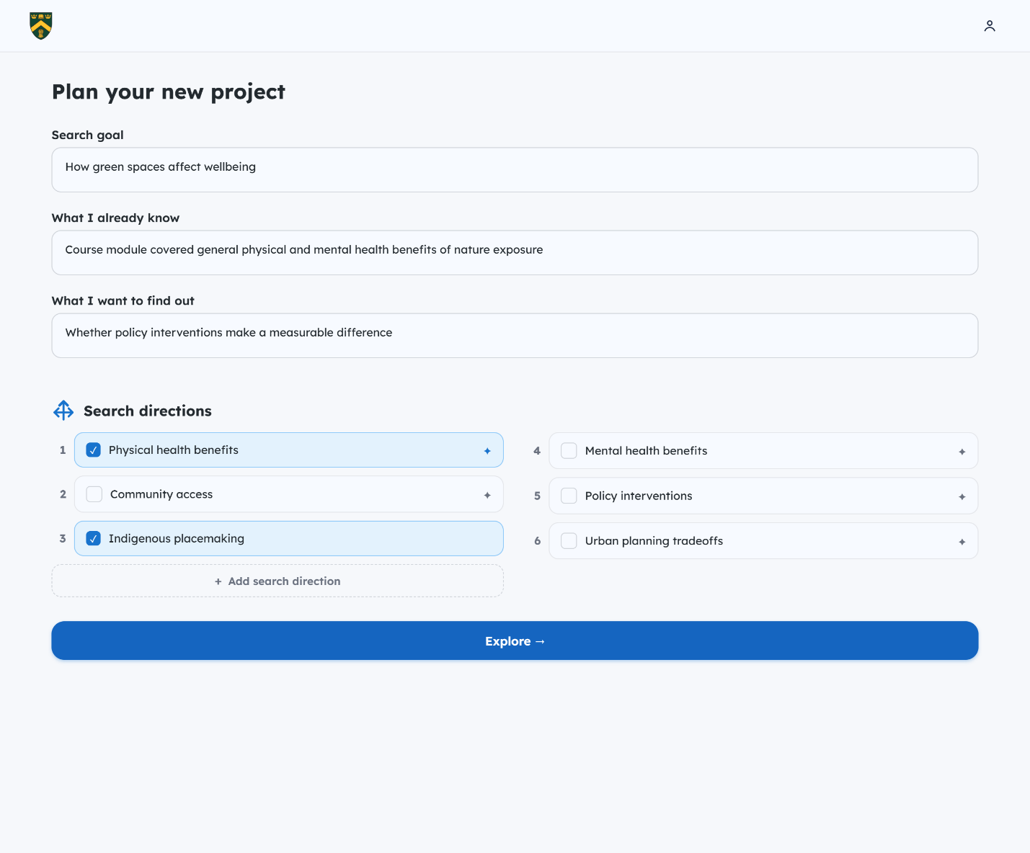
Fig 1: Screen 1 — Plan Your New Workspace

The LLM proposes the candidates, and the searcher decides which to work with, because GenAI scaffolding has been argued to support task management and metacognition when it offers prompts and awareness instead of automating the user’s process (Zhu et al. 2026). The list externalizes the goal-setting and strategy-identification that Crescenzi et al. treat as part of planning (Crescenzi et al. 2021), so Jamie does not need to hold the goal structure in mind, and the sub-goals stay on screen as the reference for the rest of the workspace, in the directions panel of the results page. Structured support for setting sub-goals with ideal characteristics has been associated with better knowledge retention than no support in a search-as-learning study (Urgo and Arguello 2024), which is why sub-goal generation is the step where the design uses its most capable model (see Implementation Note). Each candidate that the LLM proposes has a “Why?” button, a round “?” on the right edge of the candidate that appears when Jamie hovers over it or moves keyboard focus to it, and that is always visible on touch screens. Selecting the button opens a small card above the candidate, with an arrow pointing to the button and one sentence that says why searching in that direction helps with the search goal, and the card closes with its close button, the Esc key, or a click outside it. For Jamie’s community access, the sentence could read “Searching this helps you discover whether diverse communities benefit equally from urban green spaces.” The LLM writes this reason in the same step that proposes the candidate, so showing it needs no further call. A sub-goal that Jamie adds has no “Why?” button and no reason, because Jamie wrote it. Each sub-goal on the first screen also carries a small mark after its label that shows where it came from: a blue four-pointed star for a sub-goal the LLM proposed, and a round person icon for one that Jamie added or edited. The mark is always visible, so Jamie can tell proposed sub-goals from her own at a glance without opening anything, while the “Why?” button appears only on hover, keyboard focus or touch. Jamie can edit or remove any sub-goal, and a proposed sub-goal that Jamie edits becomes Jamie’s own, with no “Why?” button, because its reason explained the old wording. The reason is kept with each proposed sub-goal, selected or not, and appears again when Jamie reopens the plan. The reason gives Jamie something to weigh a candidate by, including a candidate Jamie had not thought of, and it follows the guidance to make clear why the system did what it did (Amershi et al. 2019) and to show the user why a particular output was generated (Weisz et al. 2024). The button only shows the reason, and Jamie still ticks a candidate to select it.

1.2 Planning: Query Generation
After choosing sub-goals, a searcher still has to turn each one into a query. Searchers with dyslexia struggle with this step. They have difficulty with spelling and query formulation during exploratory search (Beveridge et al. 2022), and they rewrite a query several times and recheck its spelling and phrasing before running it (Beveridge et al. 2022). In an eye-tracking study, searchers with dyslexia issued more queries than searchers without dyslexia (Palani et al. 2020) and made more phonetic errors in them (Palani et al. 2020). This is the difficulty Jamie meets in the Illustrative Scenario, where the effort of wording a query comes before any judging of results.
For this reason, the system writes the query for the searcher (Fig 2). The first time the searcher turns to a sub-goal, the LLM generates one short query, two to four plain keywords, from the sub-goal’s own words plus at most one anchor word from the search goal, and the system writes it in the search box for the searcher to run. The query stays short because the library search returns only records that contain every word, so a longer query often returns nothing. Wording a query is hard each time the searcher turns to a new sub-goal, so this support applies to every sub-goal. When Jamie turns to mental health benefits, the system writes “mental health greenspace” in the search box. When Jamie later turns to community access, a different query written for that sub-goal appears there. The system stores the query for each sub-goal. When Jamie returns to a sub-goal, the system writes the last query searched under it in the search box, whether the LLM wrote it or Jamie did, so Jamie does not have to retype earlier wording and the LLM is not called again. Because every query belongs to a sub-goal, the results it returns can later be judged against that sub-goal (see 2.1 Evaluation: Relevance and Usefulness of Results).
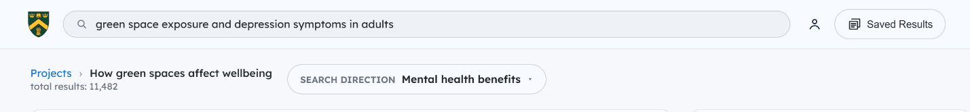
Fig 2.1: Screen 2, Results Started by a Generated Query
The searcher can edit the query and search with their own wording at any time, and the query they run becomes the one stored for that sub-goal. The LLM supplies a starting point, and the searcher keeps the decision about what to search for. The queries come from a lighter, faster model than the one used for sub-goals (see Implementation Note).

2.1 Evaluation: Relevance and Usefulness of Results
Evaluating the relevance and usefulness of the information found is a step that searchers with dyslexia find hard to do with confidence. Undergraduates with dyslexia were left unsure whether the information they found was suitable for their assignment (Beveridge et al. 2022). One participant read only the sentence containing the search term she had highlighted (Beveridge et al. 2022). Another treated only previously known information as relevant, which risks missing useful new information (Beveridge et al. 2022). Fourney et al. asked adults with and without dyslexia to rate web search results on a 5-point scale. Participants with dyslexia used only a narrow part of the scale, which suggests they have a harder time telling relevant results from non-relevant ones (Fourney et al. 2018).
MINDS takes the rating task away from the searcher. Each result on the search results page (Fig 2) is tagged with the three sub-goals it matches most strongly, and the system gives each sub-goal a rating from 0 to 5 for that result by judging how well the result’s metadata (title, abstract, and subject terms) addresses it (see Implementation Note). The searcher never sees these numbers; they are used only to put things in order. A sub-goal rated 0 is not among the tags shown by default. The tags adapt the linked-keywords principle of Hoeber and Shukla, where a keyword acts as a visual anchor tied to search results, and a controlled study of that principle showed benefits for usability, knowledge gain, and uncertainty reduction compared to a baseline academic digital library interface (Hoeber and Shukla 2022). The order of the tags carries the rating: the tag at the left names the sub-goal that fits the result best, and the tags after it follow from the stronger fit to the weaker. For example, “Mental health benefits” comes before “Community access” on the same result, which shows that the result covers mental health benefits strongly and community access only in
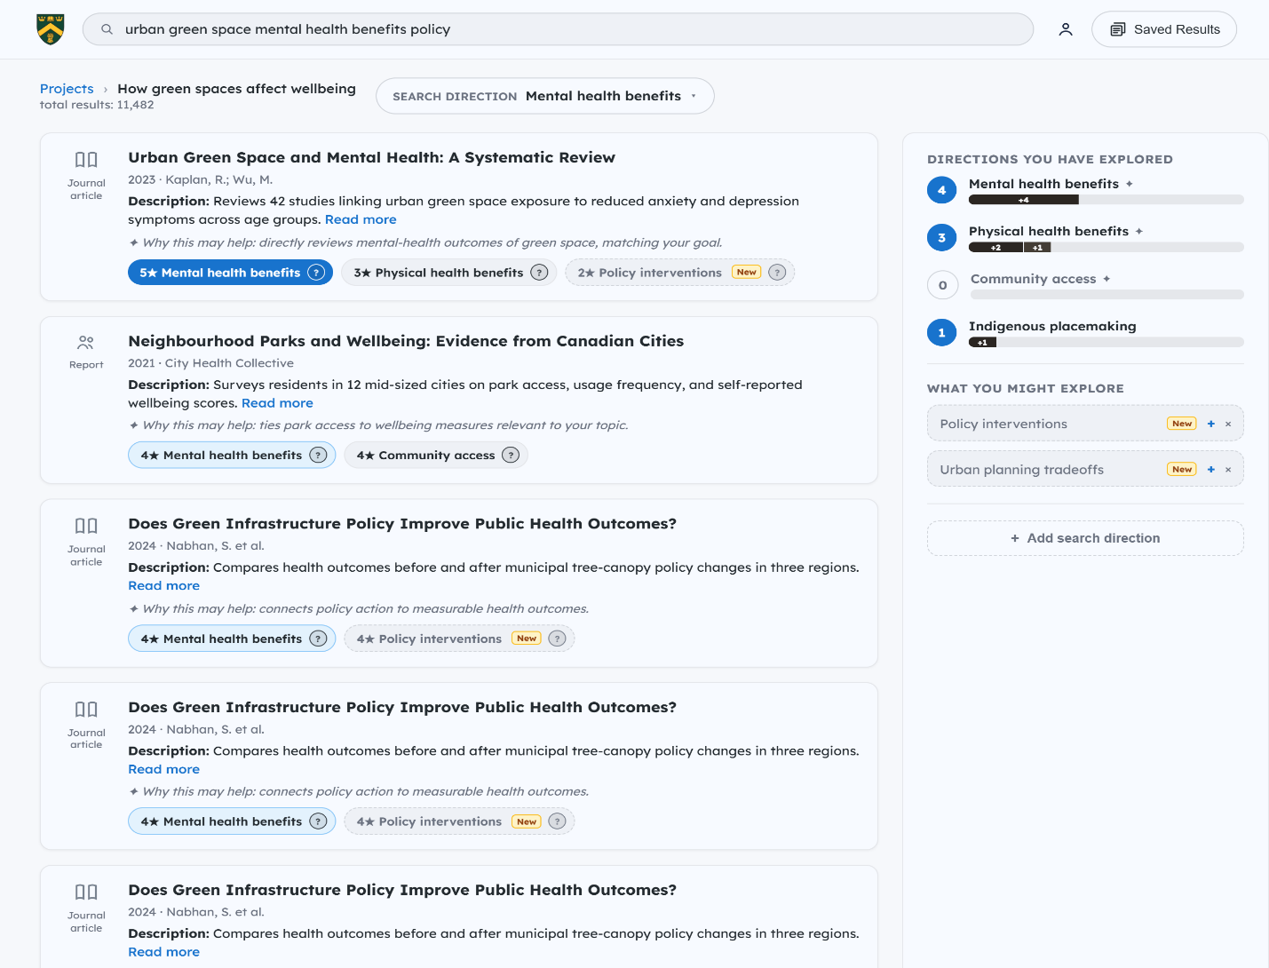
Fig 2.2: Screen 2, Search Results Page
passing. The three sub-goals with the highest ratings are shown as tags, best fit first, and no minimum rating is required. Tags with equal ratings follow the order the searcher set in the planning screen, so the sub-goal Jamie prioritized appears first. A “>>” button after the last tag reveals the remaining sub-goals, including those rated 0, so Jamie can still file a result under a weaker match. A solid blue tag with a check mark means Jamie has saved the result under that sub-goal. Every other tag is plain, and no tag or result is marked as the best match, because the order already says so. The results are ordered the same way. The results page puts the result that fits the sub-goal Jamie is searching under best at the top, and the fit falls step by step as Jamie reads down the page. This holds within each page of 10 results: when Jamie loads more, the next 10 are ordered among themselves and added below, and the results already on screen do not move. Results with equal ratings stay in the order the library returned them.
Each tag has a “(?)” icon. Selecting it shows one sentence in the result card that explains why the result may help with that sub-goal (Fig 2, inset), and selecting it again hides the sentence, so Jamie can check why the sub-goal sits where it does on that result before relying on it. Showing why a result was placed under a sub-goal follows the guidance to make clear why the system did what it did (Amershi et al. 2019) and to show the user why a particular output was generated (Weisz et al. 2024). The order and the explanations help Jamie judge a result, and the decision to open it, read it, or save it stays with Jamie. A sub-goal that Jamie added after a result was rated has no place in that result’s order yet. Its tag is shown after the ordered tags, before “>>”, and its “(?)” icon says that the result has not been rated for it and how to get that: the search icon beside the sub-goal in the right panel writes its query in the search box, and the next search rates the results against it and puts its tag in the order. Jamie can still file the result under that sub-goal in the meantime.

2.2 Evaluation: Discovering New Direction
Exploratory search does not follow a straight path. New facets of the information need are discovered while searching, which lowers the searcher’s certainty about the task and returns them to learning about the breadth of the topic (Hoeber 2025). A searcher may then decide to explore a new facet of the search scenario (Hoeber 2025). Uncertainty can rebound when a searcher discovers new subtopics to explore (Hoeber and Shukla 2022). Searchers with lower working memory may struggle to re-focus after pursuing a need prompted by information met during the session rather than by the task description (Choi and Arguello 2025). Searchers with dyslexia may judge only previously known information to be relevant, so potentially useful new information is likely to be missed (Beveridge et al. 2022).
The sub-goals planned at the start cover what Jamie knew when the workspace began. As Jamie saves results, the system looks for facets that the plan does not yet include. Once Jamie has saved at least 3 results, the LLM reads the metadata of the saved results after each save and looks for a topic that appears in at least 3 different saved results, is not already a sub-goal, and is rated above 2 on a 0 to 5 scale for relevance to Jamie’s goal. A topic that meets all three conditions is stored as a possible new sub-goal. From then on, every result on the search results page is rated against the possible new sub-goal together with the sub-goals Jamie selected. When the possible new sub-goal is among the three highest ratings for a result, it appears on that result as an extra tag marked “New”, at most one per result, placed among the other tags by its fit, so it can sit second or third (Fig 2). It also appears in the “What you might explore” panel on the right. For Jamie, a facet such as green gentrification could surface this way after several saved results mention it, without Jamie having to notice the repetition unaided.
Jamie also decides whether to add it. The system only suggests a facet, and nothing joins the plan unless Jamie adds it as a sub-goal. Selecting the “New” tag on a result adds that facet to the plan as a sub-goal and files the result under it. Jamie can also add a sub-goal manually at any time.
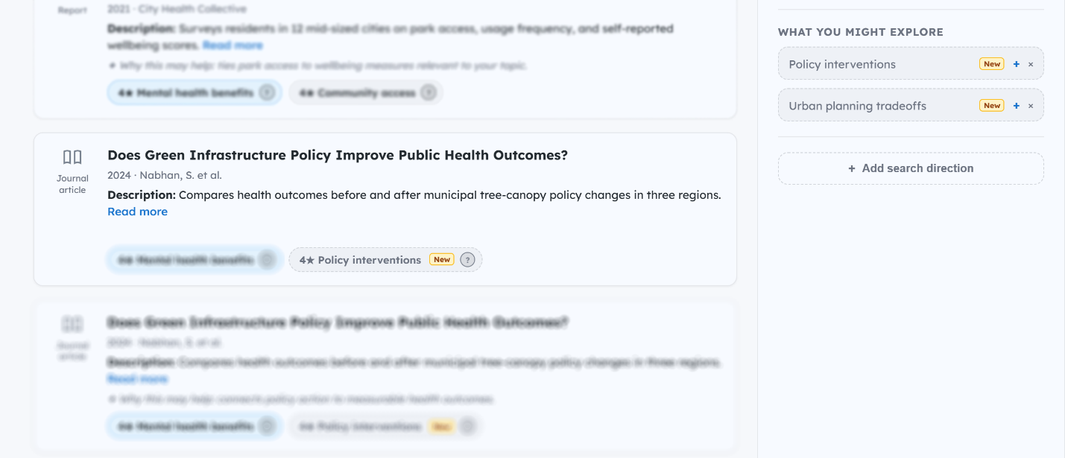
Fig 2.3: Screen 2 — SERP Showing New Directions
This lets a searcher like Jamie see at a glance which sub-goal a result speaks to most, and which come after it, without reading the result first to work that out.

2.3 Evaluation: Switching and Adding Sub-Goals
Evaluation includes judging whether the plan is working and whether the search should continue, change direction, or stop (Crescenzi et al. 2021). A change of direction can mean exploring a new facet of the search scenario or changing the search topic entirely, and an interface should let the searcher remove earlier selections or reset when they decide to do either (Hoeber 2025). MINDS supports these decisions with three actions that are always available: switching to another sub-goal, adding a sub-goal, and starting a new workspace.
The right panel lists the workspace’s sub-goals (Fig 2). Each has a search icon at its right, and pressing it switches the search to that sub-goal, whatever Jamie did last. The system stores the last query searched under each sub-goal (see Planning: Query Generation), so the switch writes that query in the search box, typed out letter by letter, and leaves the cursor in the box. The results already on the page stay until Jamie presses the search icon in the box or Enter, so Jamie can read the query, change its words if wanted, and then search, without retyping anything. What is sent from the box is stored under the sub-goal whose icon was pressed last. When the results page first opens on a sub-goal, for example after Explore, it searches that sub-goal’s query at once. This applies the persistence principle, which holds that interactive selections should persist so that the searcher does not have to repeat them, and which Hoeber links to keeping users in control (Hoeber 2025). Jamie can return to the sub-goal she left, carry on with the next one, or turn to one she has not touched, and the progress shown for each sub-goal (see 4 Monitoring: Progress within and across Sessions) informs that choice.
Jamie can add a sub-goal at any time. A sub-goal added later is treated like one chosen during planning: it gets a generated query, it becomes a place to file saved results, and results are rated against it from the next search on (results already on the page show its tag after the ordered tags, with no place in the order, until then). Jamie can add one that she notices herself or one the system suggests (see 2.2 Evaluation: Discovering New Facets). If Jamie wants to change topic entirely, she returns to the workspaces list, creates a new workspace, whose first screen opens with the title field ready to type in (the title can be left empty and changed later), and plans it with its own goal and sub-goals. When Jamie returns to the workspace after a break, the Continue Last Activity button resumes the last search (see Cross-Session Support: Resuming a Workspace). Jamie decides when to switch, add, or start again, and the system never changes sub-goal for her.

3 Organization: Saving into Sub-Goals
Searchers face challenges in organizing the information they find during exploratory search (Orin and Hoeber 2025). Existing tools leave the creation of the structure to the searcher. In OrgBox, searchers create, label, and rearrange the boxes themselves (Crescenzi et al. 2021). In WESearch, searchers create nested workspaces to break their search goal into sub-goals (Orin and Hoeber 2025). In SearchPath, searchers type tags, which auto-completion and default tags make easier (Seihoon et al. 2026). The structure can matter for working memory. When participants used a baseline bookmark tool, low-working-memory participants reported more difficulty than high-working-memory participants in deciding when they had enough information to complete the task, and with OrgBox the two groups reported similar difficulty (Choi et al. 2023).
MINDS builds the structure during planning (see Planning: Goal Decomposition). Each sub-goal that Jamie selects is also a place to file results, so no folder or label has to be created later. When Jamie saves a result, the sub-goal tags on the result act as the save control. Selecting a tag files the result under that sub-goal and fills the tag solid blue with a check mark, and selecting it again removes the result from that sub-goal. The tags are the ones described under Evaluation: the three best-fitting sub-goals, best fit first, with ties following the order Jamie set during planning. The ">>" button reveals the remaining sub-goals, so Jamie can file a result under a weaker match. A source on tree canopy and mental health, for example, goes under mental health benefits. Jamie decides both whether to save a result and where it goes.
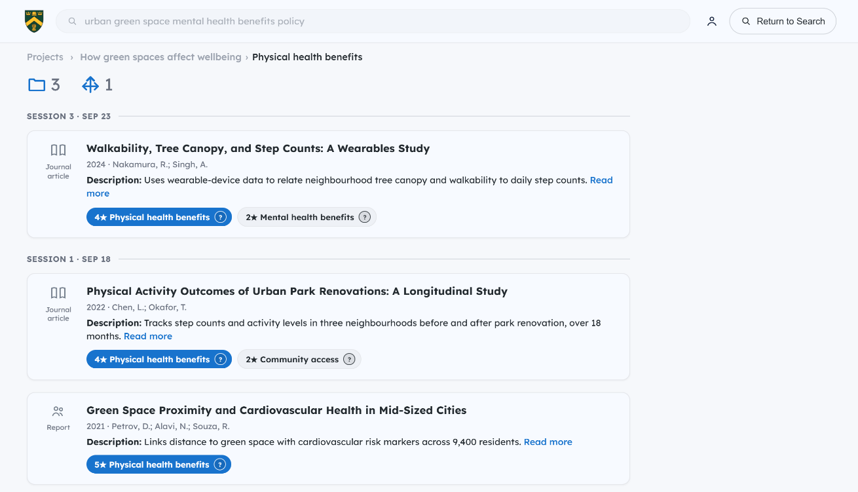
Fig 3: Screen 3 — Saved results for single sub-goal
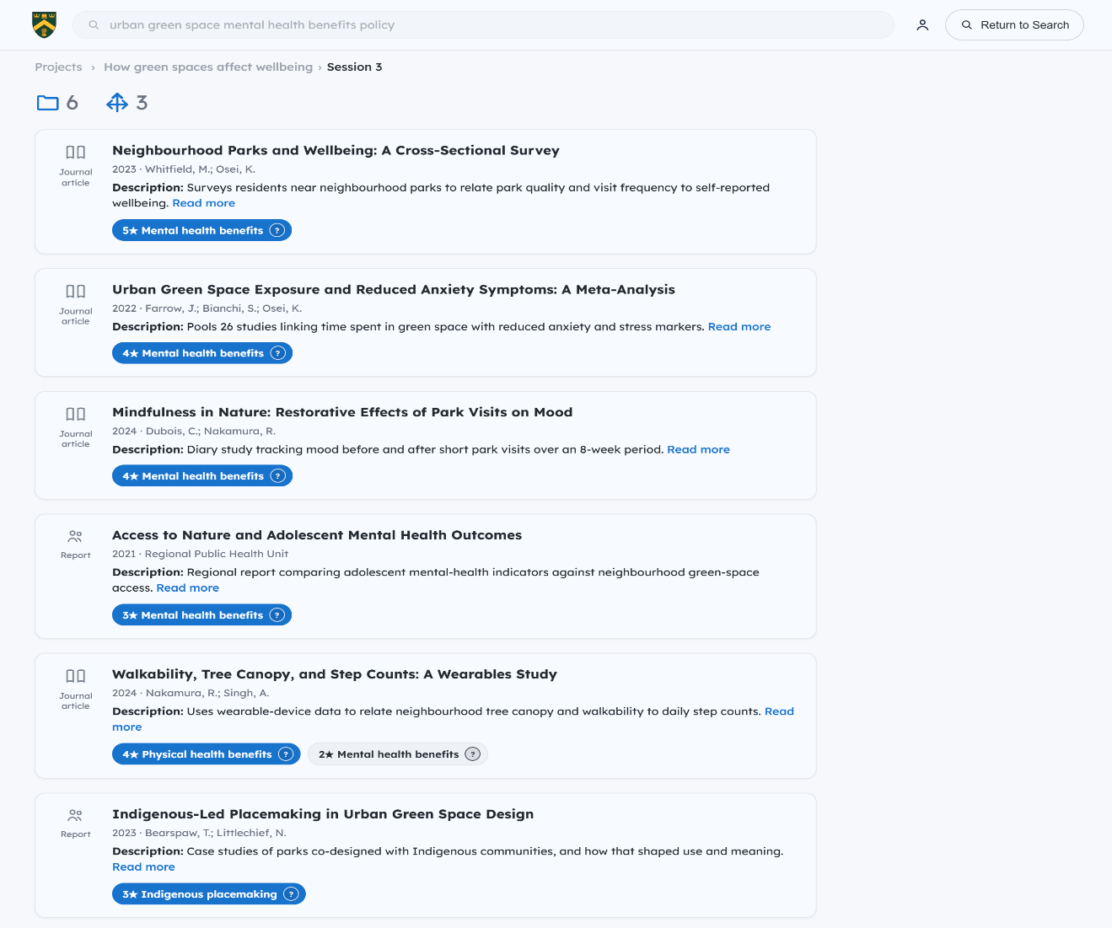
Fig 4: Screen 4 — Saved results for single session
The saved results view for a sub-goal shows everything saved under it across the workspace, with the same tags as the results page, shown only for the sub-goals the result is saved under. A row of three counts at the top gives the number of saved results, sub-goals and sessions in the view. Selecting a saved tag removes the result from that sub-goal, but the card stays on screen with a grey tag until Jamie leaves the view, so a mistaken selection can be undone by selecting the grey tag again. The same view can be limited to one session, which supports cross-session search (see Cross-Session Support: Resuming a Workspace). A panel on the right, “Directions with saved results”, lists All directions and then each sub-goal that has saved results, with the number saved under it. Selecting a name shows only the results saved under that sub-goal, without a new search, and selecting it again, or All directions, shows everything again. The selected name is solid blue. Return takes Jamie back to where the view was opened from: to the Workspace Overview, with no search box shown, when it was opened from there, and to the results page otherwise.

4 Monitoring: Progress within and across Sessions
Monitoring involves maintaining awareness of progress and of the uncertainties that remain (Crescenzi et al. 2021). High-working-memory participants engaged in more monitoring, for example by revisiting the task description to monitor their progress across subtopics (Choi and Arguello 2025). Choi and Arguello suggest that low-working-memory individuals may benefit from tools that provide a visual reminder of the different subtopics being pursued and their progress across subtopics (Choi and Arguello 2025). Exploratory search often spans several sessions, and resuming requires significant cognitive effort because searchers must reacquaint themselves with previous search activities and previously discovered documents (Gomes et al. 2022). Existing tools leave the tracking to the searcher. In WESearch, searchers set each sub-goal’s status to In Progress, Deferred, or Complete, and colour coding of these statuses helps them visually track their progress and see which areas need more attention (Orin and Hoeber 2025). Orin and Hoeber also note that this feature supports reacquaintance in cross-session searching (Orin and Hoeber 2025).
MINDS shows progress beside the results, so Jamie can monitor it during a session (Fig 2). The right panel, “Directions for this session”, lists every sub-goal with a circle and a progress bar. The circle shows how many results Jamie has saved under that sub-goal, and a sub-goal with nothing saved, such as community access, shows 0. The bar grows as Jamie saves results, so Jamie does not mark progress by hand, and it is divided into one segment per session, labelled with the number saved in that session (Fig 2). The segments use the same session colours on the results page and on the Workspace Overview: the newest session near black, the one before it slate grey, and older sessions light grey with a thin outline. All the bars share one scale, and a bar is full at 10 saved results, so Jamie can compare their lengths and see which sub-goals are ahead and which are behind. Past 10, the newest session’s segment shows only the results that fit, and a “+N more” at the right end of the sub-goal’s name line gives the rest, so the circle still shows the true total. After a distraction, Jamie can look at the panel and see where the search stands. The bar counts what Jamie has saved. It does not claim that a sub-goal is complete, and Jamie decides when a sub-goal has enough.
A version of this panel appears on the Workspace Overview screen that Jamie sees on returning to the workspace, so the support carries across sessions (Fig 5). The bar for physical health benefits, for example, shows two results saved in Session 1 followed by one saved in Session 3, and its circle shows the total of three. The Sessions panel on the left lists every session with its date, its active time, the sub-goals Jamie saved results under in that session with the number saved under each (a sub-goal with nothing saved in that session is left out), and the total saved. Session 3 was active for 34 minutes and saved 4 results under mental health benefits, 1 under physical health benefits, and 1 under Indigenous placemaking. The newest session’s tile shows a breathing blue “Running” status while its last activity was within the past hour, and a tile lists at most six sub-goals, with “+N more” for the rest. The screen opens with a header card holding the workspace path, the title “Workspace Overview” and the Continue Last Activity button. The directions list has a filter, All and Explored. With All, the selected sub-goals sit under “Selected Directions” and the unselected ones under “Unselected directions”. With Explored, the sub-goals with at least one saved or reviewed result sit under “Explored Directions” and the rest, selected or not, under “Unexplored directions”. Each card has a tick circle that selects or unselects the sub-goal, and a sub-goal that Jamie added herself carries a small person icon. Under the list, Generate more and Add Custom work as on the first screen, and what they add starts unselected. Jamie can read progress across sessions without having to recall it.
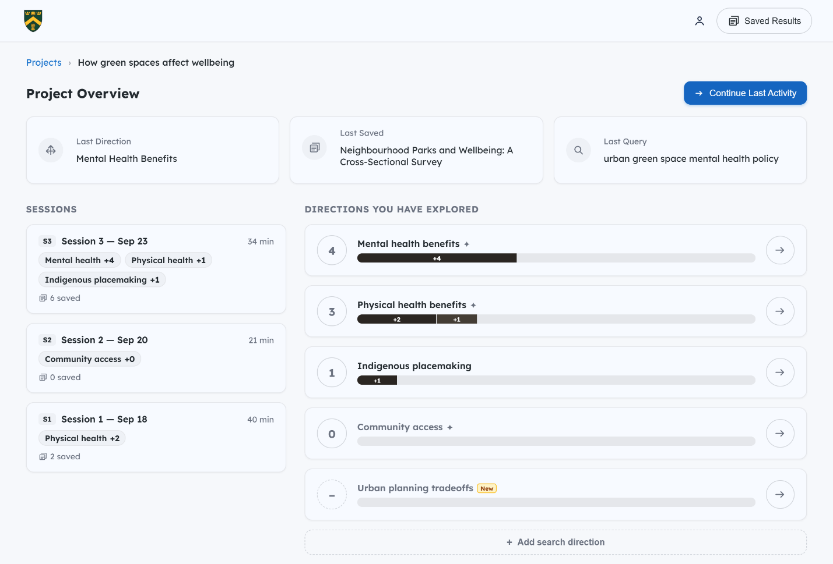
Fig 5: Screen 5, Workspace Overview

5 Cross-Session Support: Resuming a Workspace
When a searcher returns to a workspace after a break, reacquainting themselves with the earlier work takes significant cognitive effort (Gomes et al. 2022). The ability to accurately recall details such as past queries is constrained (Gomes et al. 2022), and searchers commonly reacquaint themselves by reviewing saved information, re-reading their own notes, or re-issuing previous queries (Gomes et al. 2022). Interfaces that save resources often lose the context for why a particular resource was saved (Hoeber, Islam, et al. 2026). In a controlled study, participants who used Search Timelines, an interface that shows past queries and saved resources as a timeline, reported higher engagement, usability, and perceived knowledge gain when resuming a search after 7 to 8 days (Hoeber, Islam, et al. 2026). Hoeber also advises that interactions persist across search sessions (Hoeber 2025).
When Jamie returns to the workspace, the Workspace Overview screen (Fig 5) shows the previous search activity. Three cards at the top show the last sub-goal Jamie searched, the last result Jamie saved, and the last query Jamie ran. These are the things that searchers otherwise re-find by hand, and they are shown without Jamie having to ask. The Continue Last Activity button then reopens that sub-goal with that query, so Jamie can pick up the search where it stopped. The Sessions panel and the progress bars described above sit on the same screen (see Monitoring: Progress within and across Sessions).
The Sessions panel on this screen applies the encoding specificity principle. According to Tulving and Thomson, the properties of an effective retrieval cue are determined by the specific encoding operations performed on the input (Tulving and Thomson 1973). In their experiments, subjects consistently failed to recognize many list words that they could recall when given the cue that had accompanied each word at study (Tulving and Thomson 1973). Each session in the panel is shown with the sub-goals Jamie saved results under in it, and these are the labels Jamie chose in planning and saw each time a result was filed. The cue Jamie meets on returning therefore matches how the saved results were originally encoded, in the same way that the cue paired with each word at study matched its encoding in Tulving and Thomson’s experiments.
Jamie can also resume somewhere else. Pressing the search icon beside any sub-goal in the Directions panel on the results page switches to it, whatever Jamie did last, and writes the last query searched under it in the search box (see Evaluation: Switching and Adding Sub-Goals). A facet Jamie added from a suggestion during the latest session, such as green gentrification, carries a “New” tag in the list until that session ends; a suggestion Jamie has not added is not in this list and stays in the “What you might explore” panel on the results page. Jamie can add a sub-goal with Add Custom or Generate more, or return to the workspaces list and start a new workspace.
The Saved Results button opens the saved results of the whole workspace, grouped by session with the newest session first. A count circle in the progress panel opens the saved results for that sub-goal, a bar segment opens that sub-goal’s results for one session, and a session tile on the overview opens that session’s results. The view for one sub-goal (Fig 3) groups its results by session, so Jamie can see what was saved under it in each session. The view for one session (Fig 4) shows everything saved in that session across sub-goals. Both views show a tag for each sub-goal a result is saved under, so each result still shows which sub-goals Jamie filed it under. Jamie chooses where to resume, and Continue Last Activity is a shortcut that Jamie does not have to use.

Keeping the Searcher in Control
External support brings a tension. People often use external resources to reduce cognitive effort, and this offloading may change how information is processed, remembered, and retrieved (Risko and Gilbert 2016). When a GenAI chat component was added to a search system, participants used it to avoid searching and to save time and energy (Yang et al. 2025), and they engaged less with the search results (Yang et al. 2025). In a co-design study with students with ADHD and experts, the experts named over-reliance on GenAI as a pitfall (Zhu et al. 2026), and the authors advocate that GenAI go beyond simply producing a finished plan (Zhu et al. 2026). MINDS therefore divides the work. It takes over effort that does not build understanding, such as wording queries, tracking what has been saved, and remembering earlier sessions. Reading, judging, and deciding stay with the searcher.
This division shows at each step. In planning, the LLM offers candidate sub-goals, each with a “Why?” button that shows the reason it was proposed, and Jamie chooses which to work with and can add others. Jamie can change any generated query and search with their own wording, which fits the strategy of offering ways to improve outputs by editing them (Weisz et al. 2024). On the results page, the order of the results and the order of the sub-goal tags are cues for judging a result, and Jamie decides whether to open it, read it, and save it, and under which sub-goal. Facets suggested by the system appear in the “What you might explore” panel, and Jamie adds or dismisses each one, so none joins the plan unless Jamie adds it. This follows the guideline to make it easy to dismiss or ignore undesired AI system services (Amershi et al. 2019). The system does not read the results for Jamie, does not write summaries of them, and does not choose the next step. Continue Last Activity is a shortcut that Jamie can ignore.
The “(?)” icon on each tag lets Jamie check why the system placed a tag where it did before relying on it. This follows the guideline to make clear why the system did what it did (Amershi et al. 2019) and the strategy of showing the user why a particular output was generated (Weisz et al. 2024). Whether these choices reduce the demand on working memory without reducing Jamie’s own engagement with the sources is what the user study will assess.

Implementation Note: Matching AI Techniques to Each Task
The four AI-driven components of MINDS require different underlying techniques, and matching each technique to its task is treated as a design decision in its own right. Sub-goal generation shapes the planning step that Urgo and Arguello show, through their comparison of structured subgoal-setting support against none, influences a searcher's downstream outcomes (Urgo and Arguello 2024), and therefore warrants a capable generative model: for a searcher like Jamie, a shallow or generic set of sub-goals at this step could mean a dimension of the topic, such as the policy angle in the Illustrative Scenario, never surfaces as an option to add, undermining the goal-setting activity the rest of the design depends on. Query generation is a narrower, more mechanical task and can use a lighter, faster generative model without a meaningful loss of quality, since it does not carry the same downstream weight. Result scoring and new-direction detection are judgment tasks over short metadata, so they use a generative model with a fixed rubric and a fixed output structure.
The rating described under Evaluation is computed by a generative model in a second stage, after the library search has retrieved the results. Text embeddings were considered for this step but not used, for three reasons. Cosine similarity measures how close two texts are in topic, not whether a result helps with a sub-goal. Similarity values for related texts cluster in a narrow range, so thresholds would need recalibrating for every result set. And an embedding can neither give a reason for its score nor name a new direction. Instead, for each page of 10 results, one call sends the model the metadata the library returns for each result (title, abstract, and subject terms, never the full text), together with the sub-goals Jamie selected and any stored possible new sub-goals. The model returns a whole-number rating from 0 to 5 for each result and sub-goal pair, using a written rubric whose levels describe what the result says about the sub-goal, and a short reason based on the metadata. The call uses temperature 0 and a fixed output structure to keep ratings as consistent as possible, and rating 10 results per call limits the delay before the page appears. The ratings are stored and used only to put things in order: the three highest per result become the tags, best first, and the results are ordered by the rating for the sub-goal Jamie is searching under. Jamie never sees the numbers. The rubric is set empirically, by comparing the order the ratings produce against searchers’ own judgments of relevance.
New-direction detection runs in the background after Jamie saves a result, once at least 3 results are saved. One call sends the model the metadata of the saved results and the current plan, and returns topics that appear in at least 3 different saved results and are not in the plan, each rated from 0 to 5 for relevance to Jamie’s goal. Counting distinct saved results and applying the threshold are done by code outside the model, and only topics rated above 2 are stored, with at most three active at a time. The model only proposes a direction; Jamie decides whether it joins the plan.

Task List

Phase 1: MVP Design & Build

September 17 – October 5: Design Freeze
- Update wireframe screens and design documentation based on a final design architecture review, so coding does not start against a moving target.
- Complete a feature-by-feature audit mapping every wireframe element to a specific problem or literature finding, noting where each feature diverges from Momeni and Hoeber's (2026) interactive cluster refinement and from Seihoon et al.'s (2026) SearchPath.
- Ground the definition of "scaffolding" against the broader information retrieval literature, to strengthen the Related Work section.
- Reframe the presentation to open with the persona and task scenario, add slide numbers, fix non-standard terminology (e.g., "LVSIP"), and state upfront where and how generative AI is used, for the Fall CS 900 review.

October 5 – November 5: Build the MVP
- Set up the project and integrate a search source (API or index) for the SERP, with LLM-based query generation for a sub-goal the first time it is opened.
- Implement the planning screen: goal and prior-knowledge input, with LLM-based sub-goal generation and selection.
- Implement the SERP relevance ordering: a generative model rates each result against each selected sub-goal as a whole number from 0 to 5 using a written rubric, and the ratings order the tags on each result and the results on the page without being shown as numbers; treat the rubric as provisional pending empirical validation.
- Implement goal-linked saving so the searcher files a result by selecting a sub-goal tag on it, and saved results can be viewed by sub-goal and by session.
- Implement session logging and the Workspace Overview screen (last-activity cards, Continue Last Activity, the Sessions panel, and per-session progress bars).
- Integrate all components end to end into a working MVP and confirm through informal use that the mechanisms behave as intended and that the research questions remain valid and interesting before locking in the study protocol.

Phase 2: Study Design & Ethics Application

November 5 – November 20: Decisions That Shape the Protocol
- Map each MINDS feature to the specific metacognitive activity it targets (planning, monitoring, or evaluating), grounded in how the MVP actually implements it rather than in the original design intent alone.
- Adopt Crescenzi et al.'s (2021) planning, monitoring, and evaluation instrument, the same one Momeni and Hoeber (2026) reused, as the basis for the study's metacognition measure, used as-is.
- Decide the user study's population strategy: working memory capacity as a continuous measure, diagnosed dyslexia or ADHD recruitment, or both. This directly determines the study's participant recruitment criteria and screening instruments for the REB application.

November 20 – December 5: Protocol and Ethics Submission
- Design the user study protocol: participant selection, task scenario, metrics, and analysis plan, reflecting the population strategy decided above and the MVP's actual behavior.
- Select the baseline condition MINDS will be compared against.
- Draft the research ethics (REB) application and supporting study materials.
- Incorporate Fall CS 900 review feedback into the study protocol and ethics application.
- Submit the REB application.

Phase 3: Heuristic Evaluation & Cognitive Walkthroughs (While REB Review Is Pending)

December 5 onward, through the REB review period
- Run heuristic evaluations of the MVP against established usability heuristics, independent of the REB timeline.
- Conduct cognitive walkthroughs of each of the five MINDS mechanisms to identify points where a searcher's expected action diverges from what the interface supports.
- Fix defects and refine the interface based on findings from the heuristic evaluations and cognitive walkthroughs.
- Validate the rubric behind the ratings (1 to 5) against searchers' own judgments of result relevance during the cognitive walkthroughs, and revise it if the order the ratings produce does not match what searchers actually judge as relevant.
- Address any requested REB revisions as they arrive.
- Finalize participant recruitment materials pending approval.

Fall 2026 Goals
1. By October 5: Design freeze: wireframes, feature-to-problem audit, and presentation finalized for the Fall CS 900 review.
2. By November 5: MVP complete: planning, query generation, relevance ordering, goal-linked saving, and the Workspace Overview and saved results screens integrated and confirmed through informal use.
3. By December 5: Study protocol finalized and the REB ethics application submitted.
4. By December 15: Heuristic evaluations and cognitive walkthroughs of the MVP underway, with defects fixed and recruitment materials finalized ahead of REB approval.

Dissemination
The proposed venue for dissemination is a demo paper at CHIIR or a poster at ASIS&T, followed by a full paper at CHIIR or a journal article in JASIST, IPM, or TOIS.

Coursework
- First CS 900 (Winter 2026): literature and understanding
- Second CS 900 (Summer 2026): design and implementation
- Third CS 900 (Fall 2026): implementation, study design, ethics application
- Fourth CS 900 (Winter 2027): data collection and writing
- Fifth CS 900 (Summer 2027): defence and further dissemination

Acknowledgments
The author gratefully acknowledges the guidance of Dr. Orland Hoeber and the members of the Interactive Information Retrieval research group at the University of Regina.

References
[1] Lynne Beveridge, Stephann Makri, and Andrew MacFarlane. 2022. "I'm just not sure." The persistence of uncertainty in the information seeking of undergraduate students with dyslexia. Information Research 27, Special Issue (2022), ISIC 2022. DOI:https://doi.org/10.47989/irisic2207
[2] Arthur Câmara, Nirmal Roy, David Maxwell, and Claudia Hauff. 2021. Searching to learn with instructional scaffolding. In Proceedings of the 2021 Conference on Human Information Interaction and Retrieval (CHIIR '21). ACM Press, New York, NY, 209–218. DOI:https://doi.org/10.1145/3406522.3446012
[3] Bogeum Choi and Jaime Arguello. 2025. The effects of working memory during a search and sensemaking task. In Proceedings of the 2025 ACM SIGIR Conference on Human Information Interaction and Retrieval (CHIIR '25). ACM Press, New York, NY, Pages 100 - 111. DOI: https://doi.org/10.1145/3698204.3716449
[4] Bogeum Choi, Jaime Arguello, Robert Capra, and Austin R. Ward. 2023. The influences of a knowledge representation tool on searchers with varying cognitive abilities. ACM Transactions on Information Systems, Volume 41, Issue 1 Article No.: 18, Pages 1 – 35 https://doi.org/10.1145/3527661
[5] Anita Crescenzi, Austin R. Ward, Yuan Li, and Rob Capra. 2021. Supporting metacognition during exploratory search with the OrgBox. In Proceedings of the 44th International ACM SIGIR Conference on Research and Development in Information Retrieval (SIGIR '21). ACM Press, New York, NY, Pages 1197 – 1207. DOI: https://doi.org/10.1145/3404835.3462955
[6] Adam Fourney, Meredith Ringel Morris, Abdullah Ali, and Laura Vonessen. 2018. Assessing the readability of web search results for searchers with dyslexia. In Proceedings of the 41st International ACM SIGIR Conference on Research and Development in Information Retrieval (SIGIR '18). ACM Press, New York, NY, Pages 1069 - 1072. DOI:https://doi.org/10.1145/3209978.3210072
[7] Sebastian Gomes, Miriam Boon, and Orland Hoeber. 2022. A study of cross-session cross-device search within an academic digital library. In Proceedings of the 45th International ACM SIGIR Conference on Research and Development in Information Retrieval (SIGIR '22). ACM Press, New York, NY, 384–394. DOI:https://doi.org/10.1145/3477495.3531929
[8] Orland Hoeber. 2025. Design principles for exploratory search interfaces. In Proceedings of the 2025 ACM SIGIR Conference on Human Information Interaction and Retrieval (CHIIR '25). ACM Press, New York, NY, 12–22. DOI:https://doi.org/10.1145/3698204.3716443
[9] Orland Hoeber, Md Nazmul Islam, Miriam Boon, Dale Storie, and Veronica Ramshaw. 2026. Search Timelines: Visualizing search history to enable cross-session exploratory search. International Journal on Digital Libraries 27, 1 (Mar. 2026), Article 4. DOI:https://doi.org/10.1007/s00799-026-00439-x
[10] Orland Hoeber, Abbas Pirmoradi, Sebastian Gomes, Baran Erfani, Zakiyyah Noorally, and Yug Shah. 2024. Visual keyword/result linking: Using interaction to dynamically reveal relationships. In Proceedings of the 2024 ACM SIGIR Conference on Human Information Interaction and Retrieval (CHIIR '24). ACM Press, New York, NY, 66–76. DOI:https://doi.org/10.1145/3627508.3638307
[11] Orland Hoeber and Soumya Shukla. 2022. A study of visually linked keywords to support exploratory browsing in academic search. Journal of the Association for Information Science and Technology 73, 8 (2022), 1171–1191. DOI:https://doi.org/10.1002/asi.24623
[12] Hira Jamshed, Mustafa Naseem, Venkatesh Potluri, and Robin N. Brewer. 2025. Rethinking productivity with GenAI: A neurodivergent students' perspective. In Proceedings of the 27th International ACM SIGACCESS Conference on Computers and Accessibility (ASSETS '25). ACM Press, New York, NY, 1–16. DOI:https://doi.org/10.1145/3663547.3746329
[13] Tao Jiang. 2014. Exploratory search: A critical analysis of the theoretical foundations, system features, and research trends. In Library and Information Sciences: Trends and Research, Chih-Ming Chen and Ray Larsen (Eds.). Springer, 79–103. DOI:https://doi.org/10.1007/978-3-642-54812-3_7
[14] Uri Katz, Mosh Levy, and Yoav Goldberg. 2024. Knowledge Navigator: LLM-guided browsing framework for exploratory search in scientific literature. In Findings of the Association for Computational Linguistics: EMNLP 2024. Association for Computational Linguistics, Miami, FL, USA, 8838–8855. DOI:https://doi.org/10.18653/v1/2024.findings-emnlp.516
[15] Yuan Li and Rob Capra. 2024. Stopped yet complete: Exploring the relationships between session-stopping reasons, information types, and cognitive activities in cross-session searches. In Proceedings of the 2024 ACM SIGIR Conference on Human Information Interaction and Retrieval (CHIIR '24). ACM Press, New York, NY, 119–129. DOI:https://doi.org/10.1145/3627508.3638304
[16] Yuan Li, Rob Capra, and Yinglong Zhang. 2020. Everyday Cross-session Search: How and Why Do People Search Across Multiple Sessions?. In Proceedings of the 2020 Conference on Human Information Interaction and Retrieval (CHIIR '20). ACM Press, New York, NY, 163–172. DOI:https://doi.org/10.1145/3343413.3377970
[17] Yuan Li, Anita Crescenzi, Austin R. Ward, and Rob Capra. 2023. Thinking inside the box: An evaluation of a novel search-assisting tool for supporting (meta)cognition during exploratory search. Journal of the Association for Information Science and Technology 74, 9 (2023), 1049–1066. DOI:https://doi.org/10.1002/asi.24801
[18] Yiming Luo, Patrick Cheong-Iao Pang, and Shanton Chang. 2025. Enhancing exploratory learning through exploratory search with the emergence of large language models. In Proceedings of the 58th Hawaii International Conference on System Sciences (HICSS 2025). University of Hawai‘i at Mānoa, Honolulu, HI, 44–53. DOI:https://doi.org/10.24251/HICSS.2025.007
[19] A. MacFarlane, A. Albrair, C. R. Marshall, and G. Buchanan. 2012. Phonological working memory impacts on information searching: An investigation of dyslexia. In Proceedings of the 4th Information Interaction in Context Symposium (IIiX '12). ACM Press, New York, NY, 27–34. DOI:https://doi.org/10.1145/2362724.2362734
[20] Gary Marchionini. 2006. Exploratory Search: From Finding to Understanding. Communications of the ACM 49, 4 (Apr. 2006), 41–46. DOI:https://doi.org/10.1145/1121949.1121979
[21] Milad Momeni and Orland Hoeber. 2026. Does it still make sense? Organizing and summarizing resources in cross-session aggregated search. In Proceedings of the 2026 ACM SIGIR Conference on Human Information Interaction and Retrieval (CHIIR '26). ACM Press, New York, NY, 28–39. DOI:https://doi.org/10.1145/3786304.3787873
[22] Donald A. Norman. 1993. Things That Make Us Smart: Defending Human Attributes in the Age of the Machine. Addison-Wesley Publishing Company, Reading, MA.
[23] Kimeya Orin and Orland Hoeber. 2025. Organizing found information in public digital library search. In Proceedings of the 2025 ACM SIGIR Conference on Human Information Interaction and Retrieval (CHIIR '25). ACM Press, New York, NY, 358–366. DOI:https://doi.org/10.1145/3698204.3716471
[24] Srishti Palani, Adam Fourney, Shane Williams, Kevin Larson, Irina Spiridonova, and Meredith Ringel Morris. 2020. An eye tracking study of web search by people with and without dyslexia. In Proceedings of the 43rd International ACM SIGIR Conference on Research and Development in Information Retrieval (SIGIR '20). ACM Press, New York, NY, 729–738. DOI:https://doi.org/10.1145/3397271.3401103
[25] Srishti Palani, Yingyi Zhou, Sheldon Zhu, and Steven P. Dow. 2022. InterWeave: Presenting search suggestions in context scaffolds information search and synthesis. In Proceedings of the 35th Annual ACM Symposium on User Interface Software and Technology (UIST '22). ACM Press, New York, NY, Article 93, 16 pages. DOI:https://doi.org/10.1145/3526113.3545696
[26] Evan F. Risko and Sam J. Gilbert. 2016. Cognitive offloading. Trends in Cognitive Sciences 20, 9 (Sept. 2016), 676–688. DOI:https://doi.org/10.1016/j.tics.2016.07.002
[27] Anita Seihoon, Lynne Beveridge, and Orland Hoeber. 2026. SearchPath: A visual reminder of past search activity to support students with dyslexia when undertaking exploratory searches. In Proceedings of the 2026 ACM SIGIR Conference on Human Information Interaction and Retrieval (CHIIR '26). ACM Press, New York, NY, 311–315. DOI:https://doi.org/10.1145/3786304.3787926
[28] James H. Smith-Spark and John E. Fisk. 2007. Working memory functioning in developmental dyslexia. Memory 15, 1 (2007), 34–56. DOI:https://doi.org/10.1080/09658210601043384
[29] Endel Tulving and Donald M. Thomson. 1973. Encoding specificity and retrieval processes in episodic memory. Psychological Review 80, 5 (Sept. 1973), 352–373. DOI:https://doi.org/10.1037/h0020071
[30] Kelsey Urgo and Jaime Arguello. 2024. The effects of goal-setting on learning outcomes and self-regulated learning processes. In Proceedings of the 2024 ACM SIGIR Conference on Human Information Interaction and Retrieval (CHIIR '24). ACM Press, New York, NY, 278–290. DOI:https://doi.org/10.1145/3627508.3638348
[31] Ryen W. White and Resa A. Roth. 2009. Exploratory Search: Beyond the Query-Response Paradigm. Synthesis Lectures on Information Concepts, Retrieval, and Services, Vol. 1. Morgan & Claypool, San Rafael, CA, 98 pages. DOI:https://doi.org/10.2200/S00174ED1V01Y200901ICR003
[32] David Wood, Jerome S. Bruner, and Gail Ross. 1976. The role of tutoring in problem solving. Journal of Child Psychology and Psychiatry 17, 2 (Apr. 1976), 89–100. DOI:https://doi.org/10.1111/j.1469-7610.1976.tb00381.x
[33] Yuyu Yang, Kelsey Urgo, Jaime Arguello, and Robert Capra. 2025. Search+Chat: Integrating search and GenAI to support users with learning-oriented search tasks. In Proceedings of the 2025 ACM SIGIR Conference on Human Information Interaction and Retrieval (CHIIR '25). ACM Press, New York, NY, 57–70. DOI:https://doi.org/10.1145/3698204.3716446
[34] Zihao Zhu, Junnan Yu, and Yuhan Luo. 2026. Scaffolding metacognition with GenAI: Exploring design opportunities to support task management for university students with ADHD. In Proceedings of the 2026 CHI Conference on Human Factors in Computing Systems (CHI '26). ACM Press, New York, NY, Article 1530, 24 pages. DOI:https://doi.org/10.1145/3772318.3790697
[35] Lynne Cole, Andrew MacFarlane, and Stephann Makri. 2020. More than words: The impact of memory on how undergraduates with dyslexia interact with information. In Proceedings of the 2020 Conference on Human Information Interaction and Retrieval (CHIIR ’20), March 14–18, 2020, Vancouver, BC, Canada. ACM, New York, NY, USA, 353–357. https://doi.org/10.1145/3343413.3378005
[36] Yuan Li, Austin R. Ward, and Rob Capra. 2021. An analysis of information types and cognitive activities involved in cross-session search. In Proceedings of the 2021 ACM SIGIR Conference on Human Information Interaction and Retrieval (CHIIR ’21), March 14–19, 2021, Canberra, ACT, Australia. ACM, New York, NY, USA, 313–317. https://doi.org/10.1145/3406522.3446044
[37] Justin D. Weisz, Jessica He, Michael Muller, Gabriela Hoefer, Rachel Miles, and Werner Geyer. 2024. Design principles for generative AI applications. In Proceedings of the CHI Conference on Human Factors in Computing Systems (CHI ‘24). ACM Press, New York, NY, 22 pages. DOI:https://doi.org/10.1145/3613904.3642466
[38] Saleema Amershi, Dan Weld, Mihaela Vorvoreanu, Adam Fourney, Besmira Nushi, Penny Collisson, Jina Suh, Shamsi Iqbal, Paul N. Bennett, Kori Inkpen, Jaime Teevan, Ruth Kikin-Gil, and Eric Horvitz. 2019. Guidelines for human-AI interaction. In Proceedings of the CHI Conference on Human Factors in Computing Systems (CHI ‘19). ACM Press, New York, NY, 13 pages. DOI:https://doi.org/10.1145/3290605.3300233

